Guidelines for registration in the Tender Procedure Automated System

For participation in tenders and bidding process a Bidder should go through the registration procedure in the Tender Procedure Automated System (hereinafter - the System), by following the link: https://tender.lukoil.com/sap/bc/bsp/sap/zeng_self_reg/start.htm

In the drop-down menu select a country and click .

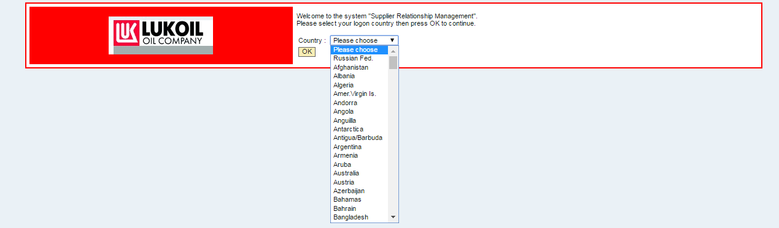

Fill in the sections on the information about the Bidders:
- Basic Data

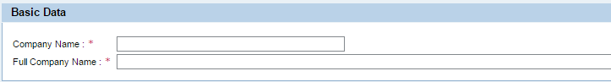

"Company Name" and "Full Company Name" fields are to be filled in Latin characters.
For Russian Federation companies, fill in the following fields: "OPF", "Company Name", "Full Company Name", "INN", "KPP" and "OGRN".

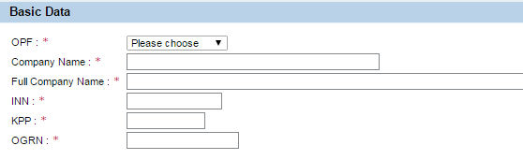

- Legal Address

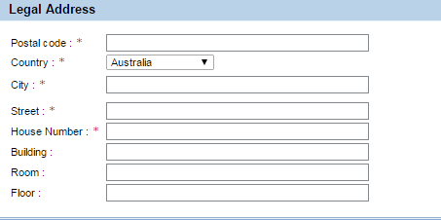

- Actual Address
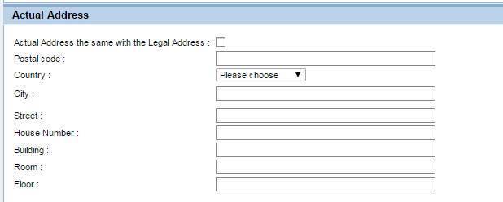

Actual Address can be entered manually or copied from the Legal Address using the tick mark:

- Contact Data

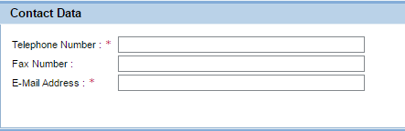

Please enter only one e-mail address in the “E-Mail address” field. Adding of addresses, separated by comma, is not acceptable.

- Contact Person (employee, authorized to work in the system)

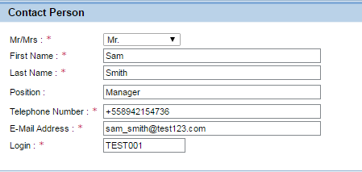

Please enter only one e-mail address in the “E-Mail address” field. Adding of addresses, separated by comma, is not acceptable. Login for entering the system should be created by users. Login shall not include blanks.

We need your approval for personal data processing. For protection from automatic registration, please enter the arithmetic operation result.

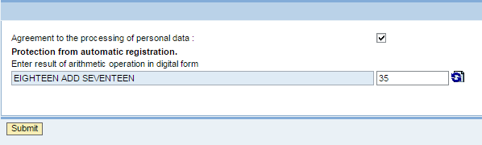

After you have filled in all data, please click Submit button. This action will be followed by the following message:

Your registration questionary has been sent.
Shortly you’ll receive a notification of the questionary’s receipt to the specified email.
In case of acceptance, the system login and password will be sent to you.
In case of favorable decision, the Bidder shall receive an e-mail with registration data (login and temporary password) and a ling for entering the system.

Then the Bidder shall follow the link, provided in the letter.
In the opened page please enter your login and password. Upon your first-time entry the system shall suggest that you change your password.

